电 子 科 技 大 学
实 验 报 告
编号：4 学号：201522060717 姓名：杨新雨

Lab 1: Vector Addition

1. Objective
The purpose of this lab is to get you familiar with using the CUDA API by implementing a simple vector addition kernel and its associated setup code.

2.运行截图
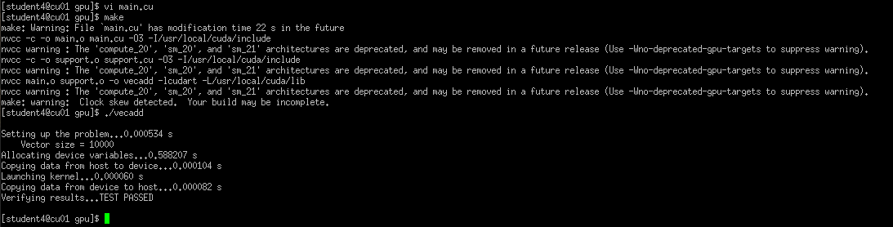

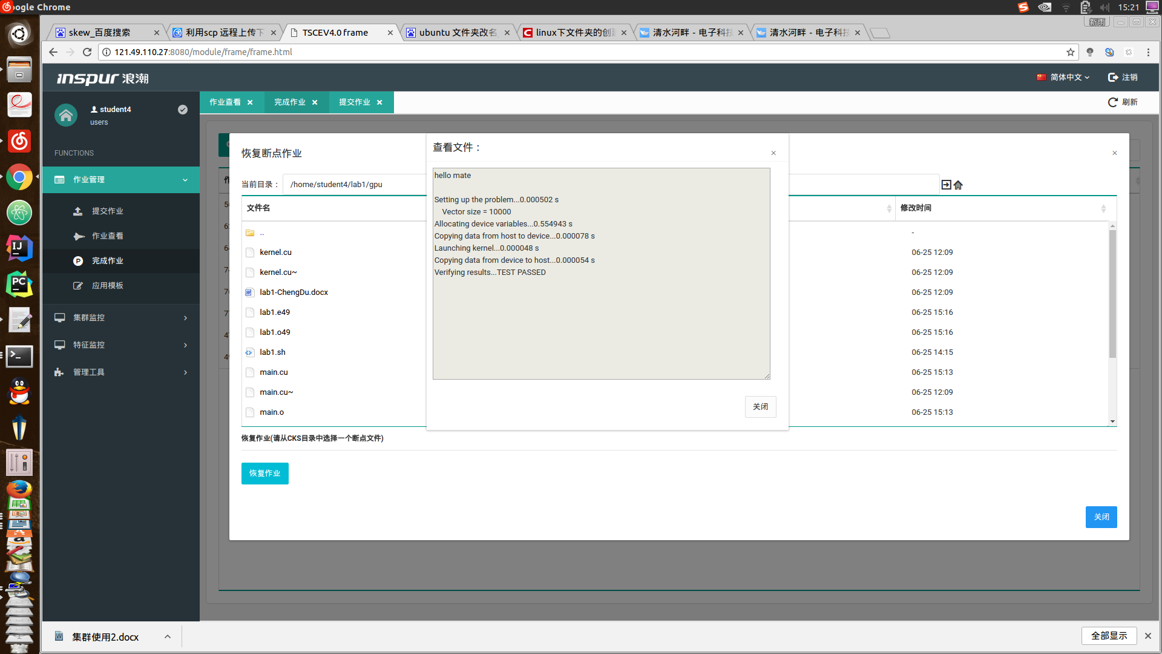

3. 部分代码

- Main.cu
/******************************************************************************
*cr
*cr (C) Copyright 2010 The Board of Trustees of the
*cr University of Illinois
*cr All Rights Reserved
*cr
******************************************************************************/

#include <stdio.h>
#include "support.h"
#include "kernel.cu"

__host__
void vecAdd(float *A_h, float *B_h, float *C_h, int n){
//d_h, d_B, d_C allocations and copies omitted
//Run ceil(n/256.0) blocks of 256 threads each
dim3 DimGrid(ceil(n/256.0), 1, 1); //定义grid维度和大小, 1表示不使用
dim3 DimBlock(256, 1, 1); //同上，一维block，每一个大小256
//vecAddKernel<<<DimGrid, DimBlock>>>(d_A, d_B, d_C, n); //d_A,d_B,d_C is not defined
}

int main(int argc, char**argv) {

Timer timer;
cudaError_t cuda_ret;

// Initialize host variables ----------------------------------------------

printf("\nSetting up the problem..."); fflush(stdout);
startTime(&timer);

unsigned int n;
if(argc == 1) {
n = 10000;
} else if(argc == 2) {
n = atoi(argv[1]);
} else {
printf("\n Invalid input parameters!"
"\n Usage: ./vecadd # Vector of size 10,000 is used"
"\n Usage: ./vecadd <m> # Vector of size m is used"
"\n");
exit(0);
}

//初始化host中A，B,C.A，B赋予随机值
float* A_h = (float*) malloc( sizeof(float)*n );
for (unsigned int i=0; i < n; i++) { A_h[i] = (rand()%100)/100.00; }

float* B_h = (float*) malloc( sizeof(float)*n );
for (unsigned int i=0; i < n; i++) { B_h[i] = (rand()%100)/100.00; }

float* C_h = (float*) malloc( sizeof(float)*n );

stopTime(&timer); printf("%f s\n", elapsedTime(timer));
printf(" Vector size = %u\n", n);

// Allocate device variables ----------------------------------------------

printf("Allocating device variables..."); fflush(stdout);
startTime(&timer);

//INSERT CODE HERE ALLOCATE DEVICE MEMORY A B AND C

//@param *h_A,*h_B:加数 *h_C:result, n:n维向量
//void vecAdd(float *A_h, float *B_h, float *C_h, int n){
int size = n * sizeof(float);
float *d_A, *d_B, *d_C;

//在gpu上分配内存,单位为byte,利用copy赋值
cudaMalloc((void **)&d_A, size);
//cudaMemcpy(d_A, A_h, size,cudaMemcpyHostToDevice);//利用copy赋值
cudaMalloc((void **)&d_B, size);
//cudaMemcpy(d_B,B_h,size,cudaMemcpyHostToDevice);
cudaMalloc((void **)&d_C, size);

//kernel invocation code- to be shown later
//cudaMemcpy(C_h, d_C,size, cudaMemcpyDeviceToHost);//完成计算后将值拷回;计算过程在哪？在kernel,cu
// cudaFree(d_A);cudaFree(d_B);cudaFree(d_C);
//}

cudaDeviceSynchronize();
stopTime(&timer); printf("%f s\n", elapsedTime(timer));

// Copy host variables to device FOR A AND B ------------------------------------------

printf("Copying data from host to device..."); fflush(stdout);
startTime(&timer);

//INSERT CODE HERE
cudaMemcpy(d_A, A_h, size,cudaMemcpyHostToDevice);
cudaMemcpy(d_B,B_h,size,cudaMemcpyHostToDevice);

cudaDeviceSynchronize();
stopTime(&timer); printf("%f s\n", elapsedTime(timer));

// Launch kernel ----------------------------------------------------------

printf("Launching kernel..."); fflush(stdout);
startTime(&timer);

//INSERT CODE HERE CONFIGURE THE GRID AND LAUNCH IT ,vecAddKernel is defined in kernel.cu
//vecAdd(A_h, B_h, C_h, n);
dim3 DimGrid(ceil(n/256.0), 1, 1); //定义grid维度和大小, 1表示不使用
dim3 DimBlock(256, 1, 1); //同上，一维block，每一个大小256
vecAddKernel<<<DimGrid, DimBlock>>>(d_A, d_B, d_C, n);

cuda_ret = cudaDeviceSynchronize();
if(cuda_ret != cudaSuccess) FATAL("Unable to launch kernel");
stopTime(&timer); printf("%f s\n", elapsedTime(timer));

// Copy device variables from host FOR C ----------------------------------------

printf("Copying data from device to host..."); fflush(stdout);
startTime(&timer);

//INSERT CODE HERE
cudaMemcpy(C_h, d_C,size, cudaMemcpyDeviceToHost);

cudaDeviceSynchronize();
stopTime(&timer); printf("%f s\n", elapsedTime(timer));

// Verify correctness -----------------------------------------------------

printf("Verifying results..."); fflush(stdout);

verify(A_h, B_h, C_h, n);

// Free memory ------------------------------------------------------------

free(A_h);
free(B_h);
free(C_h);

//INSERT CODE HERE
cudaFree(d_A);cudaFree(d_B);cudaFree(d_C);
return 0;

}

- kernel.cu
//compute vector sum c = A + B;
// Each thread performs one pair-wise addtion.

__global__ void vecAddKernel(float* A, float* B, float* C, int n) {

// Calculate global thread index based on the block and thread indices ----

//INSERT KERNEL CODE HERE
int i = threadIdx.x + blockDim.x * blockIdx.x;

// Use global index to determine which elements to read, add, and write ---

//INSERT KERNEL CODE HERE
if(i < n) C[i] = A[i] + B[i];

Lab 2: 1D Stencil

1. Objective
The purpose of this lab is to get you familiar with using the shared memory in CUDA to reduce the unnecessary global memory access. 1D stencil application should be implemented based on the slides discussed in class a simple vector addition kernel and its associated setup code.

- 实验运行截图
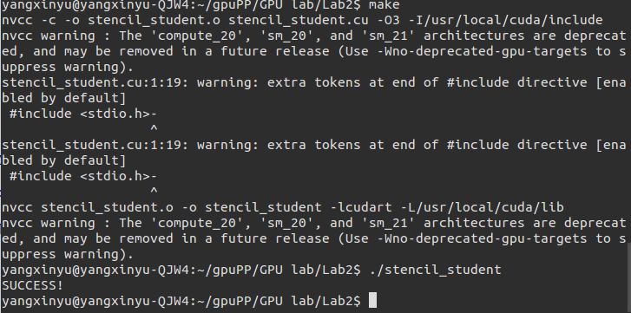

- 部分代码

Stencil.cu
#include <stdio.h>-

#define RADIUS 3
#define BLOCK_SIZE 256
#define NUM_ELEMENTS (4096*2)

// CUDA API error checking macro
#define cudaCheck(error) \
if (error != cudaSuccess) { \
printf("Fatal error: %s at %s:%d\n", \
cudaGetErrorString(error), \
__FILE__, __LINE__); \
exit(1); \
}

__global__ void stencil_1d(int *in, int *out)
{
//Add your code for the kernel
__shared__ int temp[BLOCK_SIZE + 2* RADIUS]; //shared memory
int gindex = threadIdx.x + blockIdx.x * blockDim.x+RADIUS;
int lindex = threadIdx.x +RADIUS;

//READ input elements into shared mempory:mapping
temp[lindex] = in[gindex];

//printf("temp[%d]=%d\n",lindex,temp[lindex]);
//由每个block的前面RADIUS个thread来读取halo数据
if(threadIdx.x < RADIUS){
temp[lindex - RADIUS] = in[gindex - RADIUS]; //读取前面的halo
temp[lindex + BLOCK_SIZE] = in[gindex + BLOCK_SIZE];//后面的
}

//Synchronize(ensure all data is available)
__syncthreads();

//Apply the stencil
int result = 0;
for(int offset = -RADIUS; offset <= RADIUS;offset++)
result += temp[lindex+offset];
//printf("result:%d",result);

//Store the result
out[gindex-RADIUS] = result;

}

int main()
{
unsigned int i;
int h_in[NUM_ELEMENTS + 2 * RADIUS], h_out[NUM_ELEMENTS]; //cpu memory
int size = NUM_ELEMENTS + 2 * RADIUS; //cpu memory数组长度
int *d_in, *d_out;//global memory

// Initialize host data as all 1. Add your code
//int *h_in =(int*)malloc(sizeof(int)*(NUM_ELEMENTS+RADIUS));
for (unsigned int i=0; i < size; i++) { h_in[i] = 1;}

// Allocate space on the device for d_in and d_out. Add your code
cudaMalloc((void**)&d_in,size*sizeof(int));
cudaMalloc((void**)&d_out,NUM_ELEMENTS*sizeof(int)); //???last edit here

// Copy host input data to device. Add your code
cudaMemcpy(d_in, h_in, size * sizeof(int),cudaMemcpyHostToDevice);

// Invoke the stencil_id kernel by defining the right grid and block dimension. You may need a boundary block. Add your code

//NUM_ELEMENT = 4096*2; BLOCK_SIZE = 256; -> NUM_ELEMENT/BOLCK_SIZE =32;(正好整除) but we have halo, so we should have 33 BLOCKS
dim3 DimGrid(ceil((NUM_ELEMENTS+2*RADIUS)/BLOCK_SIZE),1 ,1);
dim3 DimBlock(BLOCK_SIZE, 1, 1); //此处也应当+2*RADIUS吧。否，blocksize是block内线程的数量，而不是block内存储空间的大小
stencil_1d<<<DimGrid, DimBlock>>>(d_in,d_out);

// Copy device output data to host. Add your code
cudaMemcpy(h_out, d_out,NUM_ELEMENTS*sizeof(int),cudaMemcpyDeviceToHost);

// Verify every out value is 7. Already given
for( i = 0; i < NUM_ELEMENTS; ++i )
if (h_out[i] != 7)
{
printf("Element h_out[%d] == %d != 7\n", i, h_out[i]);
//break;
}

if (i == NUM_ELEMENTS)
printf("SUCCESS!\n");

// Free out memory. Add your code.
//free(h_in);
//free(h_out);
cudaFree(d_in);
cudaFree(d_out);

return 0;
}

